**Objective**:

The objective of the project is to predict the type of image given with both ANN and CNN.

**Outcome**:

Using CNN gives better - precision, recall, f1-score when compared with just ANN

**Tools Used**:

1. Python
2. Tensor flow, Layers for ANN and CNN
3. Matplotlib for data visualization
4. sklearn for model building
5. Jupyter notebook as IDE

**Execution**:

The data is loaded from Kaggle dataset.

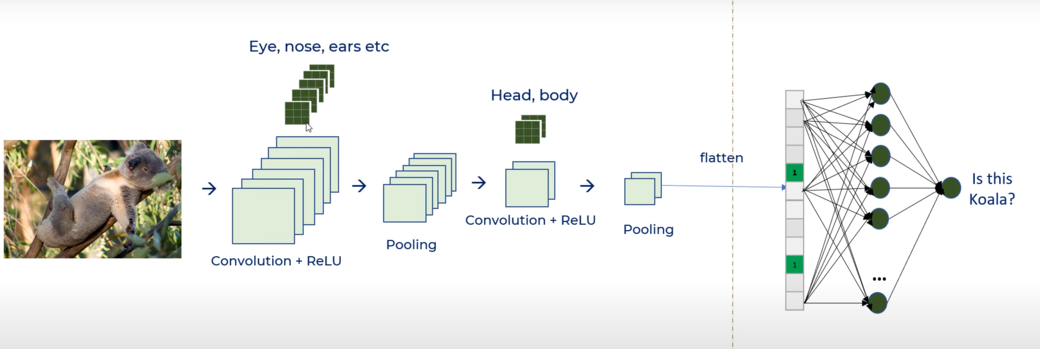

CNN applies convolution with activation function and pooling before the dense network. This improves the overall precision, recall, f1-score when compared with just ANN

Using the first part we extract the features and in the second part we flatten the dataset to be fed to fully connected Dense Neural Network